**Lab#1 Active and Passive Reconn**

|  |  |  |  |  |
| --- | --- | --- | --- | --- |
| **Tool** | **Type** | **Platform** | **Use** | **How to Use** |
| The Harvester | Passive | Linux, Windows, macOS | Harvests information from various sources | Harvests emails, subdomains, hosts, and employee names |
| Maltego | Passive | Linux, Windows, macOS | Visualizes and analyzes data relationships | Maps relationships between individuals and organizations |
| Spider Foot | Passive | Linux, Windows, macOS | Gathers information from different sources | Collects data from public sources and performs analysis |
| Shodan | Passive | Web | Searches for devices and services on the Internet | Finds devices, banners, and vulnerabilities |
| ZoomEye.org | Passive | Web | Searches for Internet-connected devices and services | Identifies open ports and services |
| Censys.io | Passive | Web | Collects data on hosts and websites | Scans for network information and vulnerabilities |
| Spyse.com | Passive | Web | Collects data on IP addresses, domains, and technologies | Gathers information about assets and technologies |
| OSINT Framework | Passive | Linux, Windows, macOS | Aggregates various OSINT tools and resources | Accesses multiple OSINT tools through a unified interface |
| FOCA | Passive | Windows | Metadata analysis in documents | Extracts metadata from documents |
| Have I Been Pwned | Passive | Web | Checks if email addresses have been part of data breaches | Searches for email addresses in data breach databases |
| Amass | Active | Linux, Windows, macOS | Subdomain enumeration and network mapping | Enumerates subdomains and discovers network infrastructure |
| Sn1per | Active | Linux, Windows | Automated reconnaissance and vulnerability scanning | Scans for vulnerabilities and potential entry points |
| Recon-NG | Active | Linux | Full-featured web reconnaissance framework | Gathers information about web applications and domains |
| SET (Social Engineering Toolkit) | Active | Linux | Social engineering attacks and credential harvesting | Creates and launches social engineering campaigns |
| Nikto | Active | Linux, Windows | Web server vulnerability scanner | Identifies vulnerabilities in web servers |
| Sublist3r | Active | Linux, Windows, macOS | Subdomain enumeration tool | Enumerates subdomains from different sources |
| Nmap | Active | Linux, Windows, macOS | Network scanning and mapping | Scans networks for open ports and services |
| Metasploit Framework | Active | Linux, Windows, macOS | Vulnerability exploitation tool | Develops, tests, and executes exploit code |
| SQLmap | Active | Linux, Windows, macOS | Automated SQL injection and database takeover tool | Exploits SQL injection vulnerabilities in web applications |
| Burp Suite | Active | Linux, Windows, macOS | Web vulnerability scanner and penetration testing tool | Identifies vulnerabilities and performs security testing on web applications |

**Part A: Active Reconnaissance with Reconnaissance Tools**

**Amass:**

Analysis:

I run "amass enum" command on the domain "meesho.com" to gather information about its DNS records, IP addresses, netblocks, and related Autonomous System Numbers (ASNs).

Here's a summary of the information I’ve obtained:

**Domain Information:**

* The domain "meesho.com" has various DNS records, including A, AAAA, CNAME, and MX records.
* It uses Cloudflare for content delivery (CDN) for several other sub-domains.
* It has multiple IP addresses associated with it.

**Name Servers:**

“meesho.com" uses Amazon AWS for its DNS hosting with name servers provided by AWS.

IP Addresses:

* The domain "meesho.com" resolves to multiple IP addresses, including 54.251.178.150,

52.77.54.140,

52.76.137.43, and more.

* Several other subdomains also have associated IP addresses.

Netblocks:

- Several netblocks are associated with the IP addresses used by "meesho.com,"

Some of them are: 205.251.192.0/21, 2600:9000:5300::/45, and others.

Autonomous System Numbers (ASNs):

- AS16509 (Amazon.com, Inc.) manages some of the IP addresses used by "meesho.com."

- AS45820 (Tata Teleservices ISP AS, IN) manages other IP addresses.

- AS14618 (Amazon.com, Inc.) and AS9498 (BHARTI Airtel Ltd., IN) also manage certain IP blocks.

- AS13335 (Cloudflare, Inc.) is involved in providing CDN services.

- AS15169 (Google LLC) and AS243 (Harris Government Systems Sector) are associated with some IP blocks.

This information can be useful for network analysis, security, and understanding the infrastructure of the "meesho.com" domain.

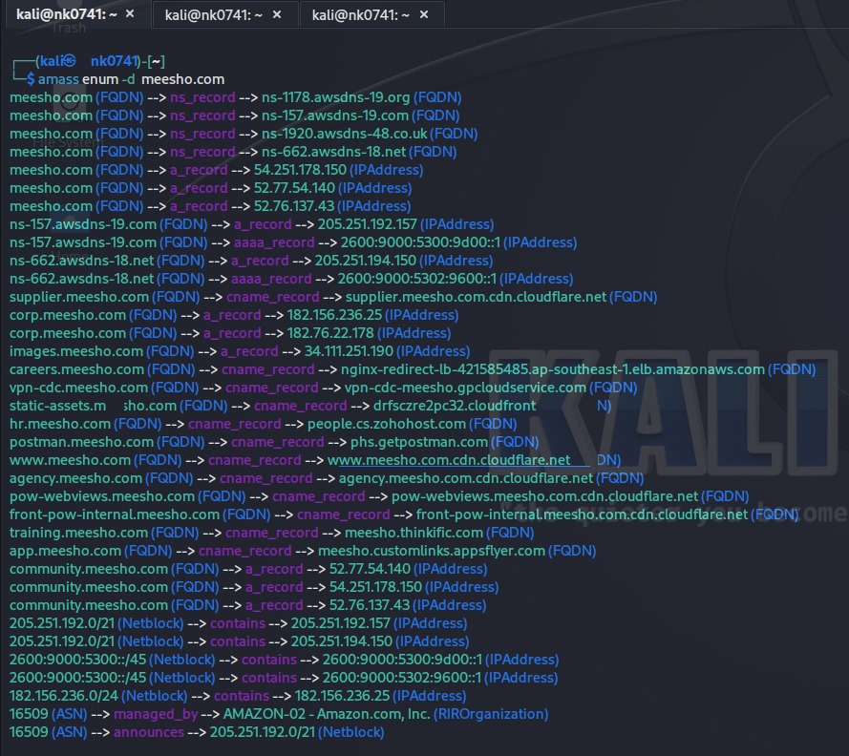

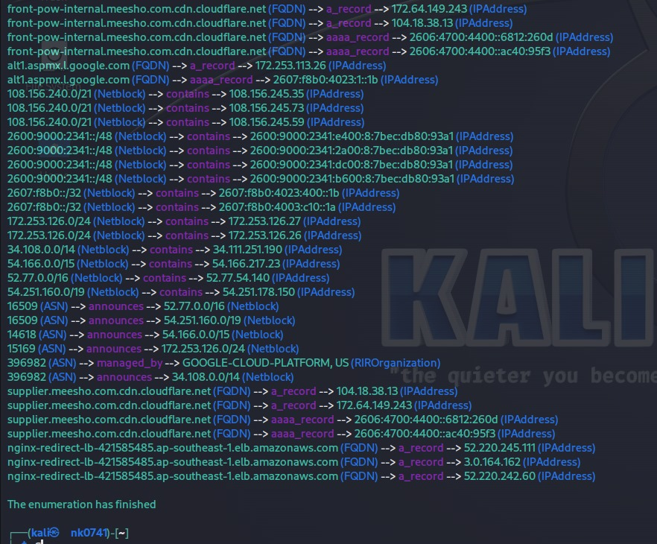

Sn1per: Sn1per is an automated tool that combines various open-source tools and scanning techniques to assist in reconnaissance and vulnerability assessment. It streamlines the information-gathering process and automates the scanning of targets to identify potential vulnerabilities.

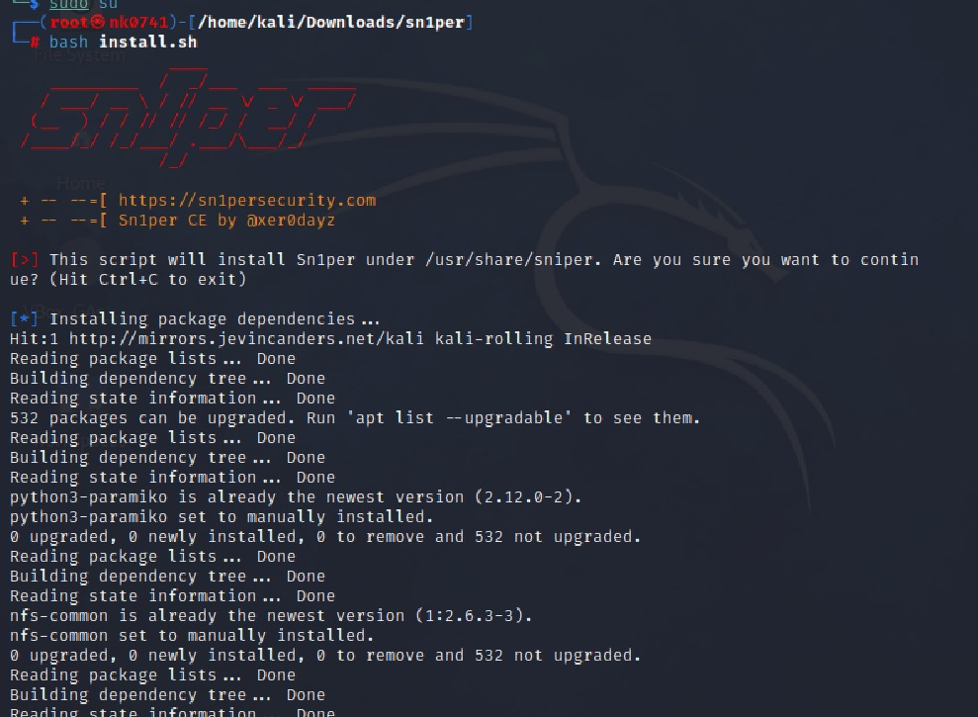

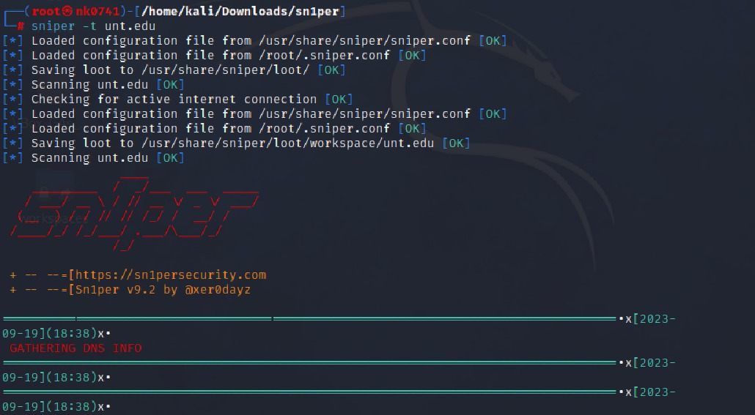

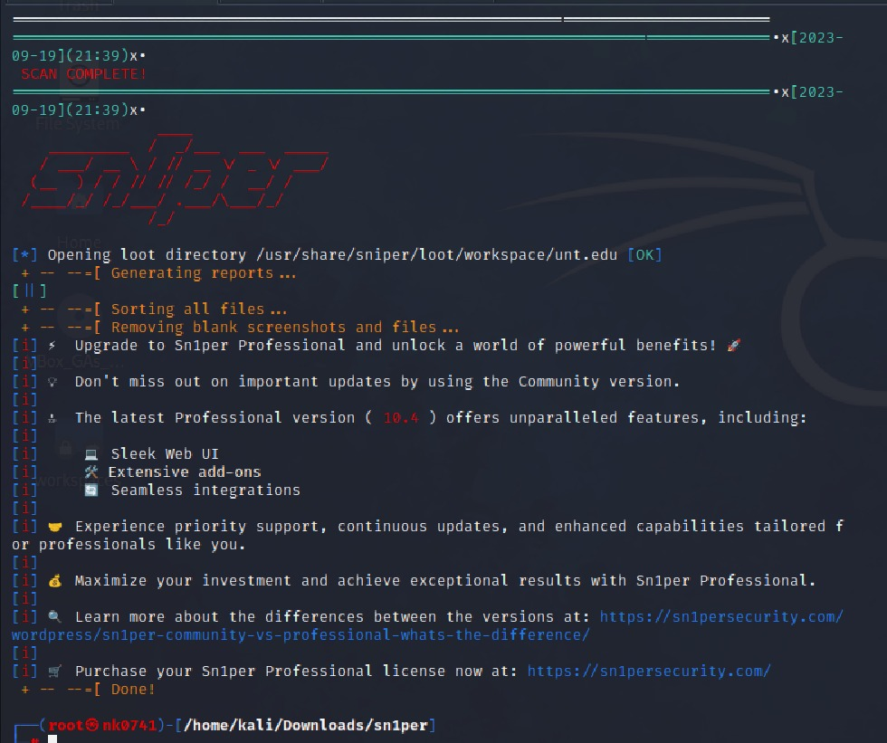

It can do the following activities: Automated Scanning

Customization

Integration of Tools

Report Generation

Port Scanning

Vulnerability Scanning

Below is the screenshot showing the results of the using sn1per and list of files in it.

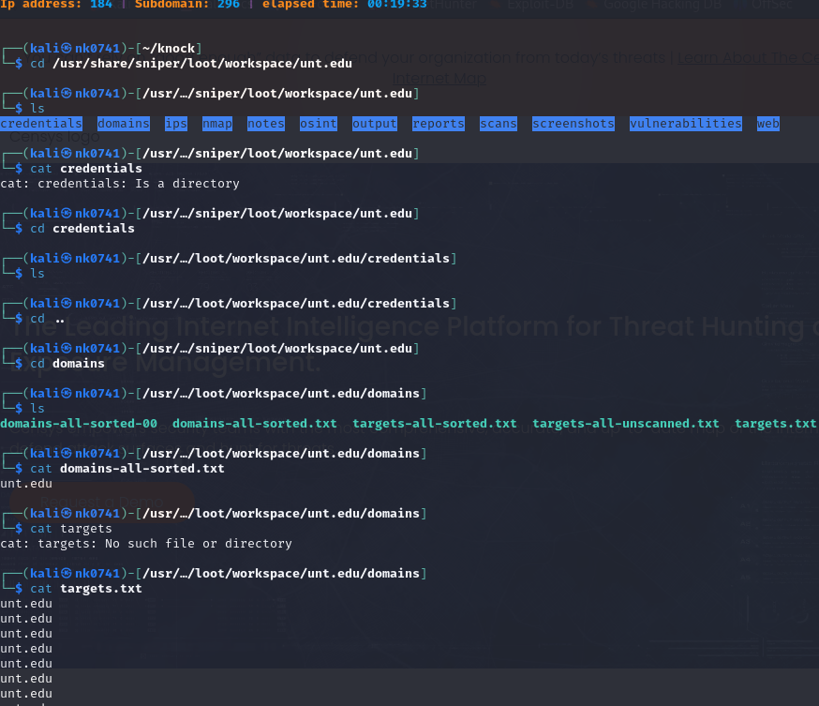

SET (Social Engineering Toolkit):

Analysis:

After trying to use the SET multiples times, below is the explanation for two of them and steps I followed to perform it.

Step 1: Choosing an Attack Vector

I chose the "Website Attack Vectors" option which is used to create web-based attacks.

Step 2: Choosing a Web Attack Method

In this step I selected the "Metasploit Browser Exploit Method" and "Java Applet Attack Method" in different instances. Both methods are designed to exploit vulnerabilities in the web browser or Java runtime of the victim's machine.

The Metasploit method utilizes selected Metasploit browser exploits through an iframe to deliver a payload,

While the Java Applet method uses a malicious Java applet to deliver the payload.

Step 3: Cloning a Website

I chose to clone a website (gmail.com) to create a malicious copy of the site.

This cloned site will host the malicious payload.

Step 4: Configuring Network Settings

It prompted to configure network settings, including whether NAT/Port Forwarding is being used and the IP address of the SET web server.

Step 5: Configuring Payload

It prompted to choose a payload for the attack. In different instances, you chose different payloads:

1. In the first instance (Metasploit Browser Exploit Method), you selected a shellcode payload targeting Mozilla Firefox.

2. In the second instance (Java Applet Attack Method), you chose the SET Interactive Shell, which is a custom reverse shell developed for SET.

Step 6: Launching the Attack

After configuring the settings, SET started a web server to host the malicious website (clone of gmail.com) with the injected payload. It seems the server started successfully, and it's ready to serve the malicious website to potential victims.

Step 7: Starting the Metasploit Framework

SET also initialized the Metasploit Framework to handle the connections from the victims when they interact with the malicious website.

Step 8: Closure

After all the setup, you chose to close the server and exit the Metasploit session, which essentially stopped the attack.

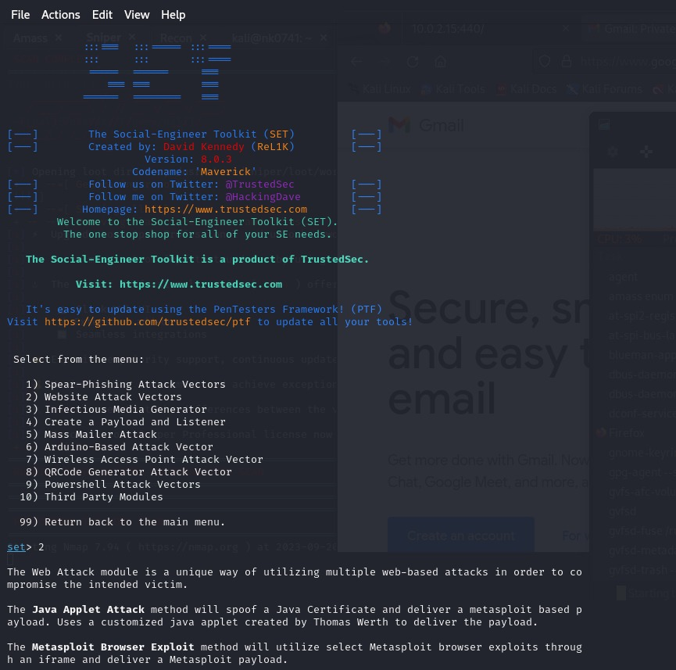

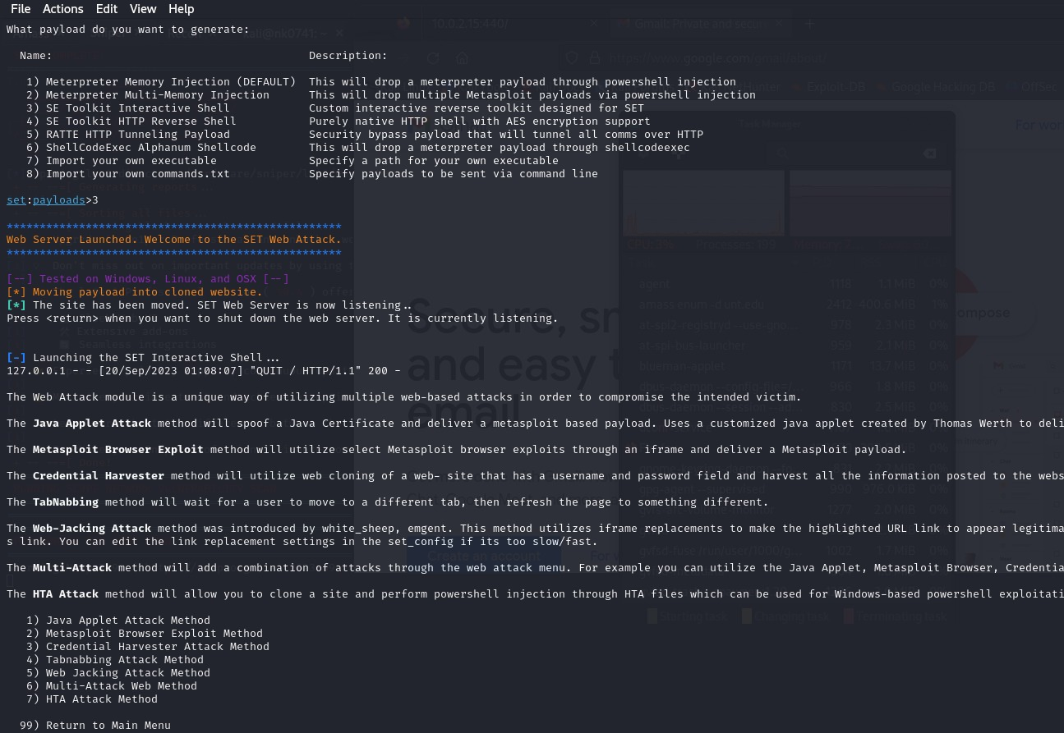

Attack-2:

In this case we selected the attack has credential harvester and tried to clone the website and you see from the below screen, we are able to get the username and password on the terminal. I hosted the cloned site on my local ip addr.

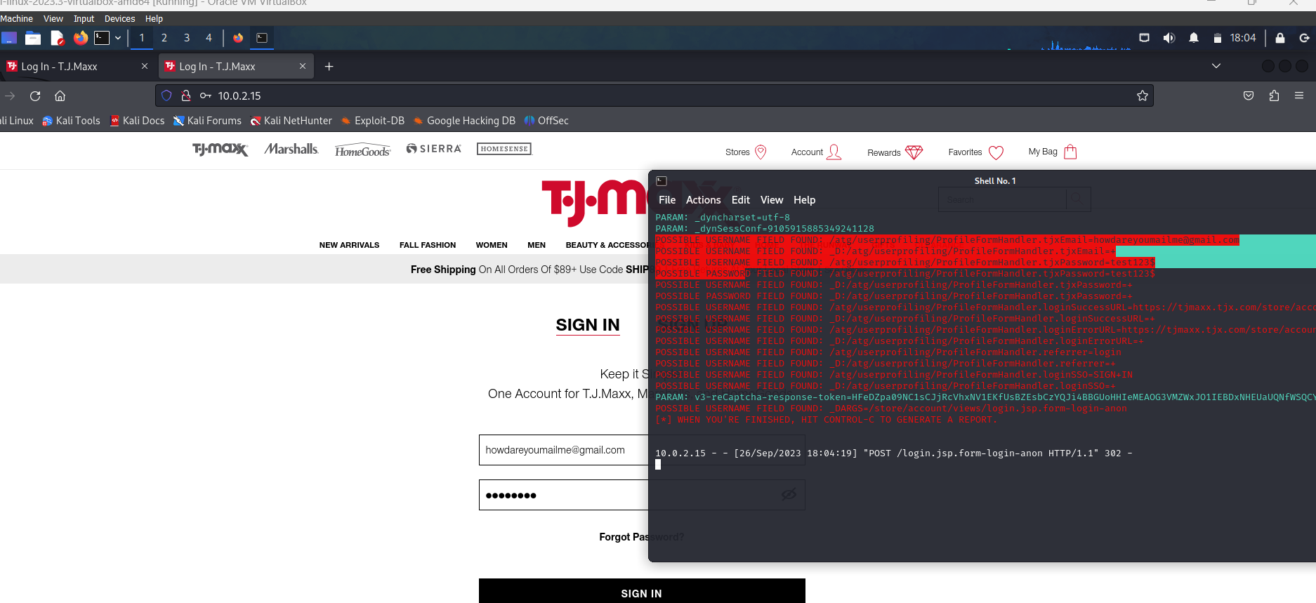

Recon-ng:

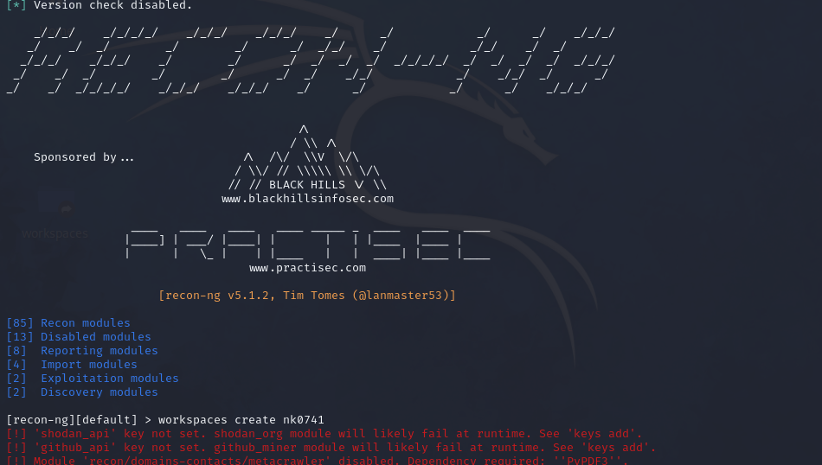

Opening Recon-ng and creating the workspace: nk0741

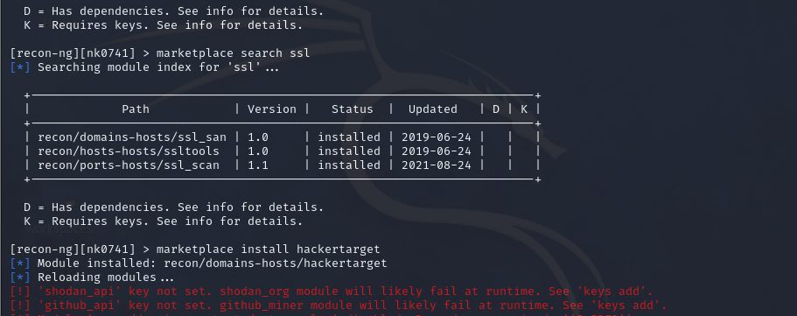

Using marketplace to search for ssl module and installing it.

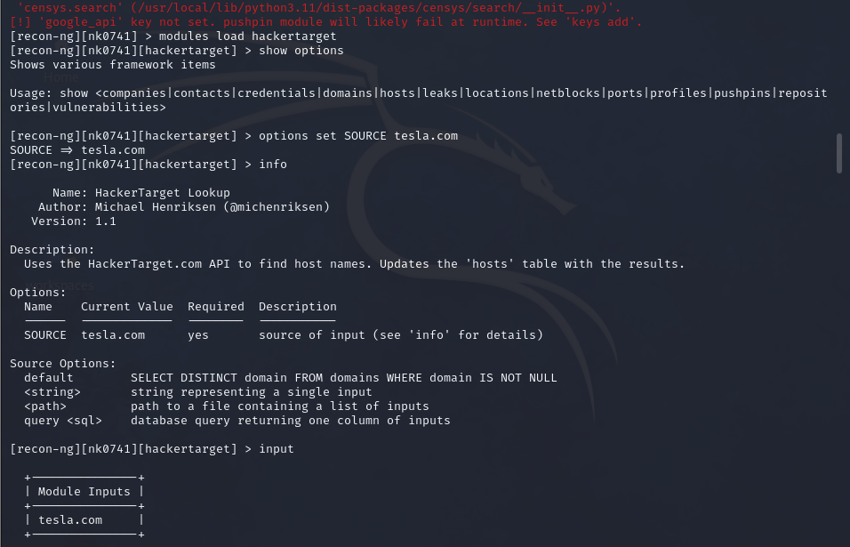

Seting option source as “tesla.com” and printing the info about it.

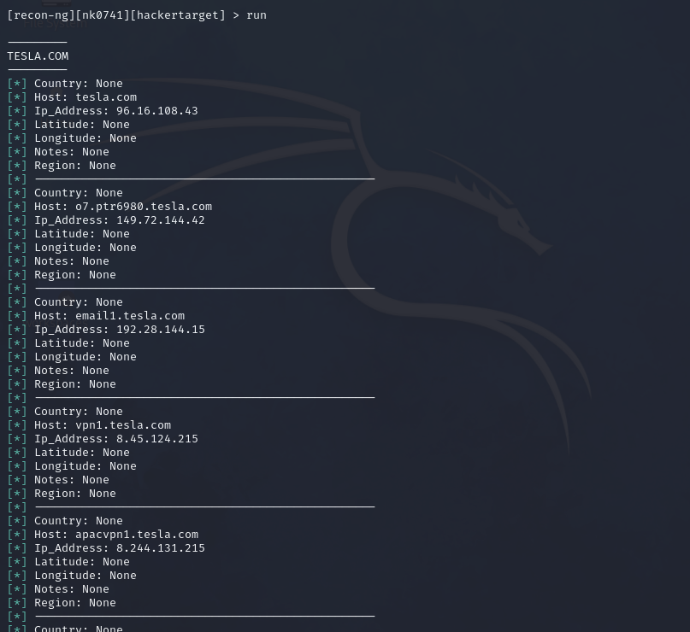

Running the module.

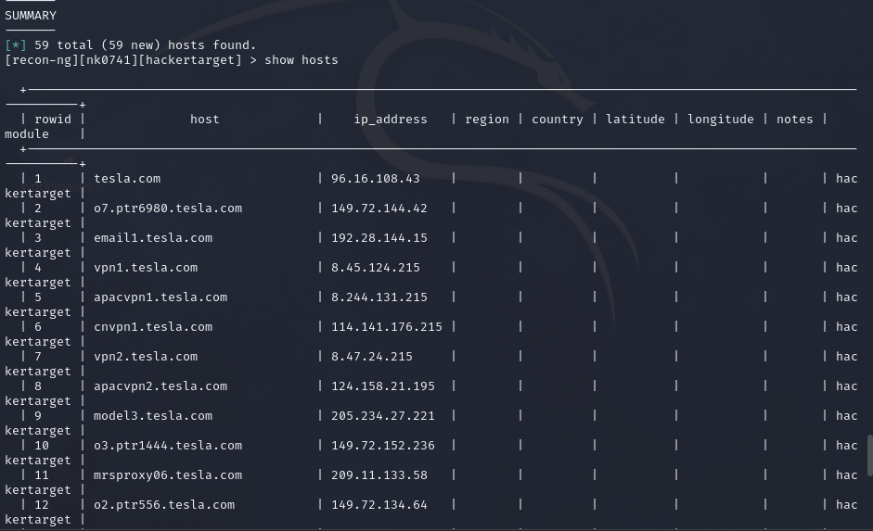

Listing all the hosts of tesla.com. As we can see we have 59 hosts in total for tesla.com

Analysis:

After starting the recon-ng and installing the required modules we have set “tesla.com” as the source and ran the modules. The above screenshot shows the results.

Nikto:

Analysis:

The result of running the Nikto web server scanner against a target IP address (40.89.244.232) that corresponds to the domain "duckduckgo.com" on port 80 (HTTP).

Breaking down the key elements of the Nikto output:

1. Start Time:

The scan started at 2023-09-20 08:07:45 (GMT-4)

1. Information on Duckduckgo.com:

Target IP: 40.89.244.232

Target Hostname: duckduckgo.com

Target Port: 80

2. Server Information:

Server: nginx

Root page / redirects to: https://duckduckgo.com/

The target server is running the nginx web server software.

3. Headers:

Several HTTP headers with uncommon names or contents were found. This can be an indicator of unusual or non-standard server configurations.

4. CGI Directories:

No CGI directories were found on the server.

5. Robots.txt:

The server's robots.txt file contains 10 entries. Robots.txt is used to specify which parts of a website should not be crawled or indexed by search engines. The entries should be manually reviewed to understand what's being restricted.

6. Multiple Index Files:

The server has multiple index files that can be used as the default page for directories. This includes common filenames like index.php, index.html, etc.

7. **Vulnerabilities and Security Issues:**

* Nikto has identified several potential vulnerabilities and security issues on the target server. These issues include:
* Detection of an admin interface for the Cobalt Qube 3.
* PHP-Survey's include file exposed via the web.
* Detection of BigIP Configuration CGI.
* Vulnerabilities in Macromedia JRun 4 build 61650 remote administration interface.
* XSS (Cross-Site Scripting) vulnerability in IlohaMail 0.8.10.
* Possible backdoor in Dansie Shopping Cart.
* Detection of the Nimda virus in a readme.eml file.
* Directory traversal vulnerability in Resin 2.1.2 view_source.jsp.
* Potential issues with MySimpleNews and ASP file upload pages.
* Exposure of .mdb database files in VP-ASP shopping cart applications.
* Information disclosure in VP-ASP shopping cart test application.
* Possible exposure of credit card data in webcart and webcart-lite configurations.
* Detection of files like ws_ftp.ini, WS_FTP.ini, and whatever.htr that may reveal sensitive information.
* More potential issues and vulnerabilities in various web applications and configurations.

8. Scan Termination:

The scan terminated due to reaching an error limit of 20. The last error encountered was a timeout while trying to connect to the server.

9. End Time:

The scan ended at 2023-09-20 08:15:21 (GMT-4) after running for 456 seconds.

In summary, Nikto has identified a different potential security issues and vulnerabilities on the “duckduckgo.com” server, ranging from unusual headers and server configurations to specific vulnerabilities in various web applications and configurations. It's important to note that the presence of these issues does not necessarily mean the server is compromised, but it does highlight areas that may require further investigation and security hardening to reduce potential risks. The server administrators should review and address these findings to enhance the server's security posture.

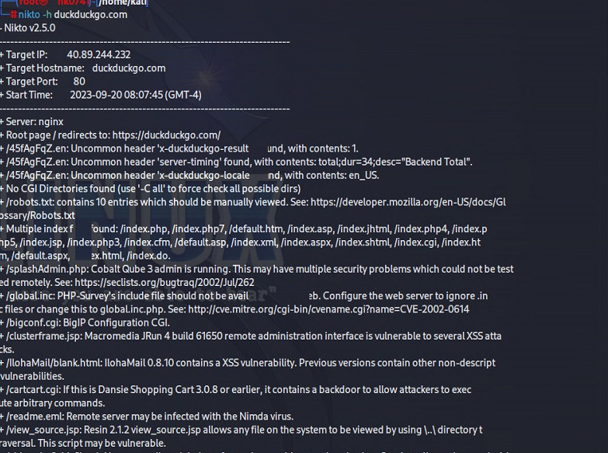

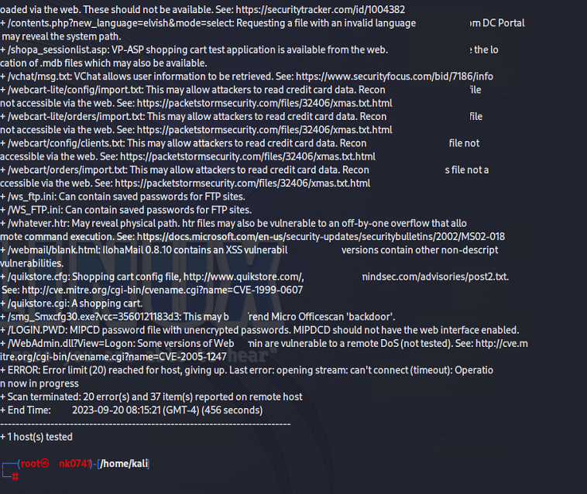

Nmap:

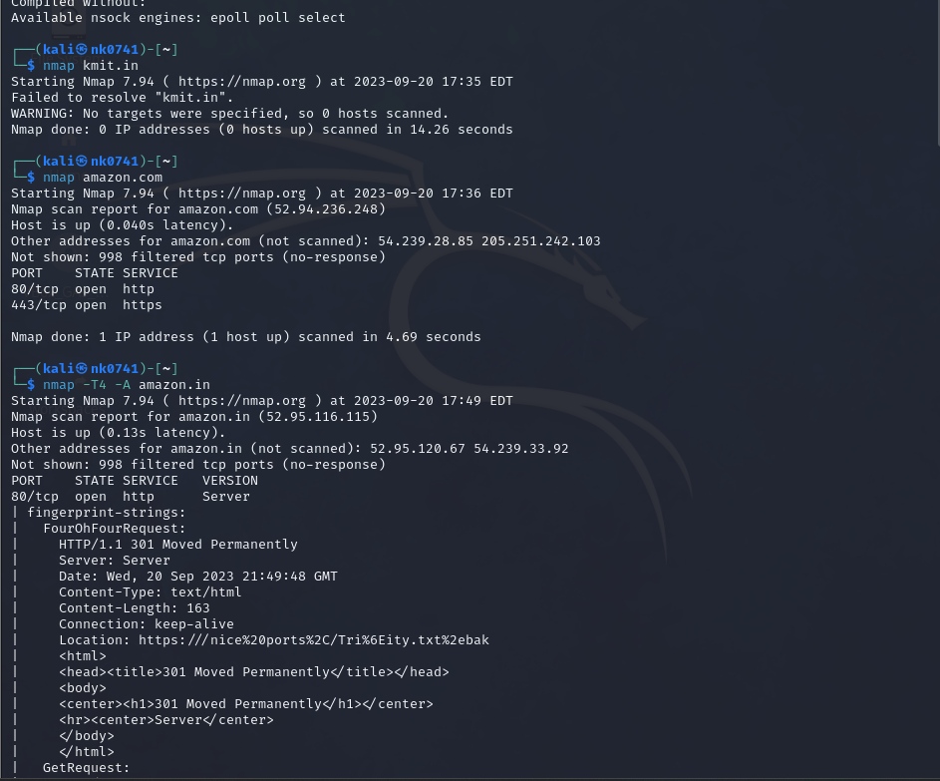

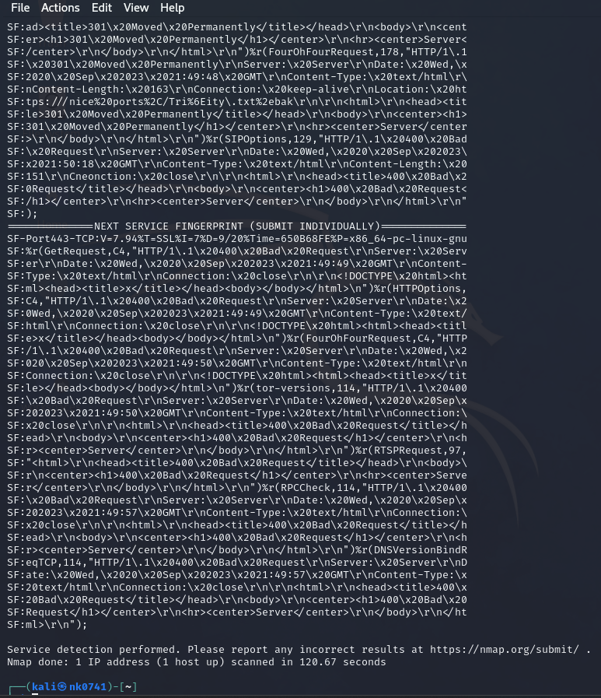

In first instance, Nmap attempted to scan the domain "kmit.in". However, it was unable to resolve the domain to an IP address. This can happen if the domain name is not valid, doesn't exist, or if there are DNS resolution issues.

In second instance, Nmap successfully resolved the domain "amazon.com" to its corresponding IP address (52.94.236.248) using DNS. It then performed a basic Nmap scan on the specified IP address.The scan revealed that the host is up with a latency of 0.040 seconds.

It identified open ports:

Port 80: Open, likely for HTTP services.

Port 443: Open, likely for HTTPS services.

Additionally, it reported that there were 998 filtered TCP ports (no-response), meaning Nmap received no response for those ports.

SQLMap:

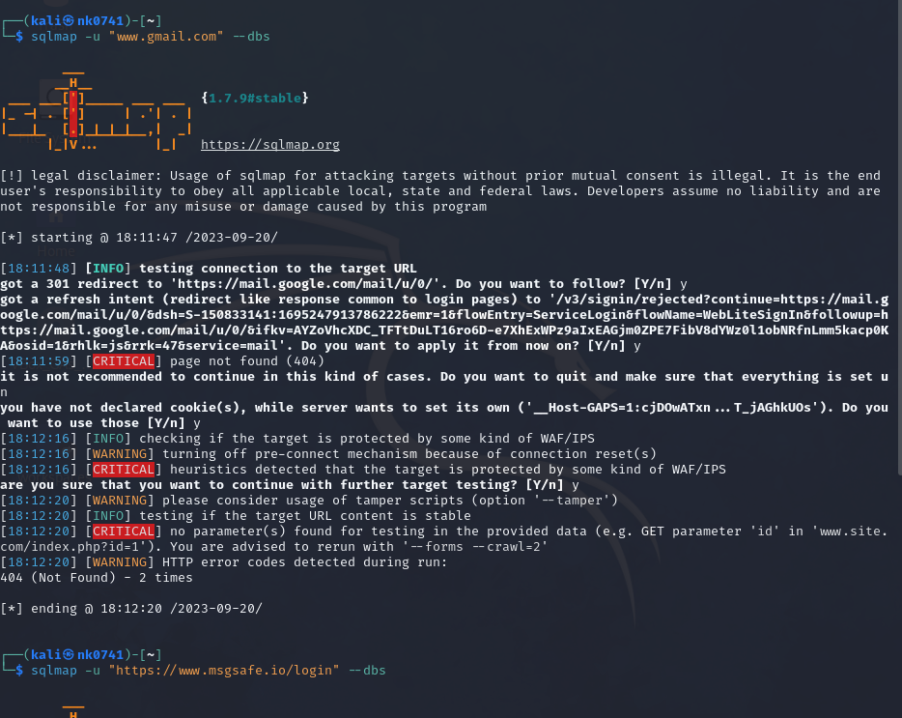

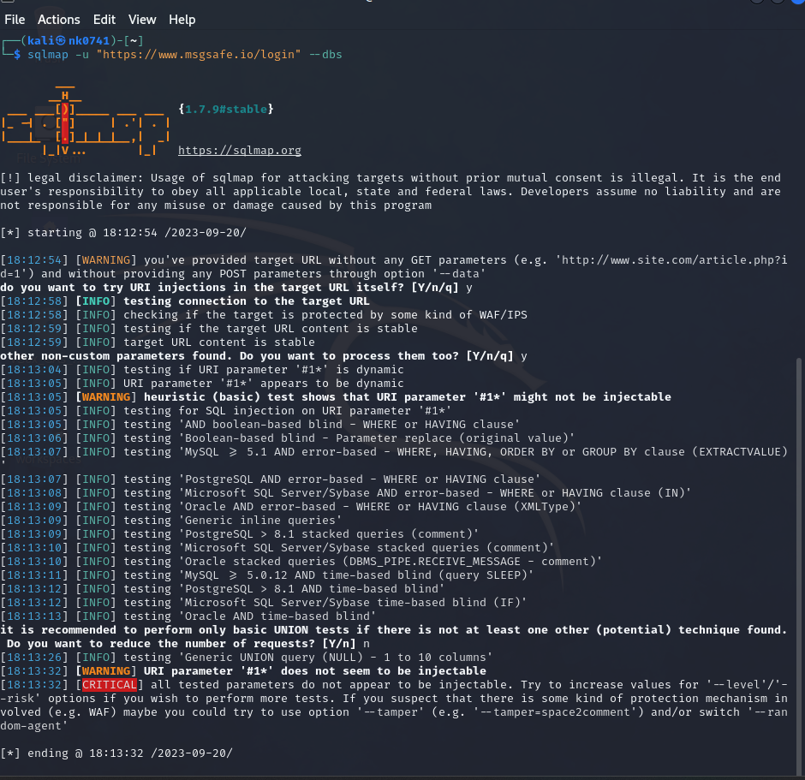

In one of instance, the target URL <https://www.msgsafe.io/login>

Breakdown of the output:

Warning and Disclaimer:

The output starts with a warning and legal disclaimer, highlighting the responsibility of the user to obey all applicable laws and the potential misuse or damage that could occur from using SQLMap without proper authorization.

Target URL without Parameters:

SQLMap warns that the provided target URL does not have any GET parameters. It asks if you want to try URI injections in the target URL itself.

Connection and Stability Checks:

SQLMap tests the connection to the target URL, checks for Web Application Firewall (WAF) or Intrusion Prevention System (IPS) protection, and verifies the stability of the target URL's content.

Dynamic Parameter Detection:

SQLMap detects a potentially dynamic URI parameter ('#1*') and proceeds to test if it's injectable for SQL injection.

SQL Injection Testing:

SQLMap tests various SQL injection techniques such as boolean-based blind, error-based, time-based blind, and UNION-based queries to determine if the detected URI parameter is vulnerable to SQL injection.

Result and Recommendation:

SQLMap concludes that the tested parameters do not appear to be injectable. It suggests increasing values for '--level'/'--risk' options if you wish to perform more tests and advises trying different tamper options or switching '--random-agent'.

BurpSuite:

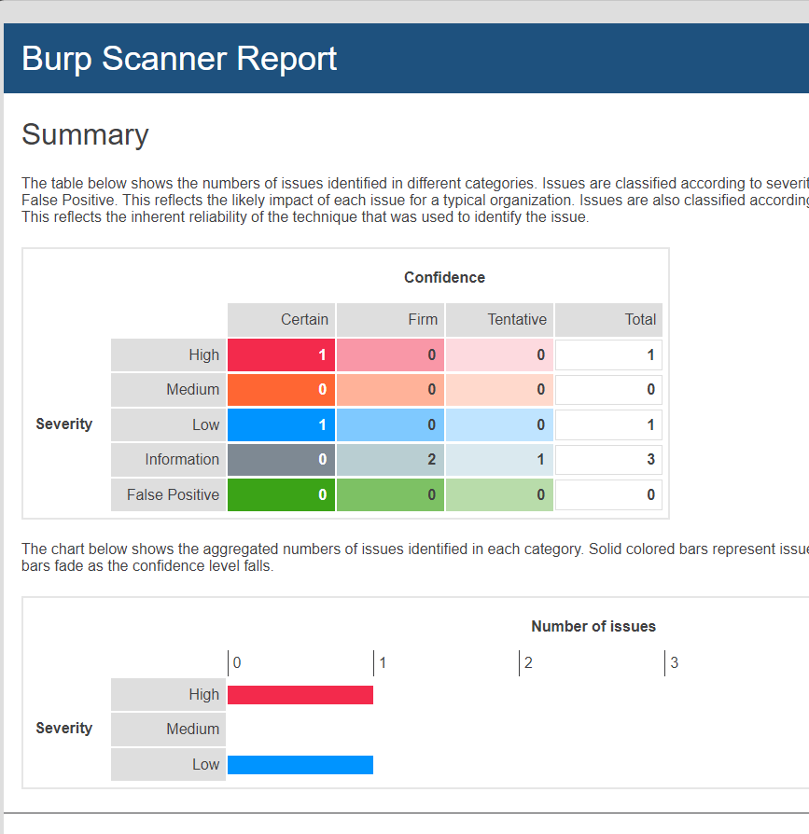

This is the Burpsuite report we generated using the professional version for learning the usage of burpsuite.

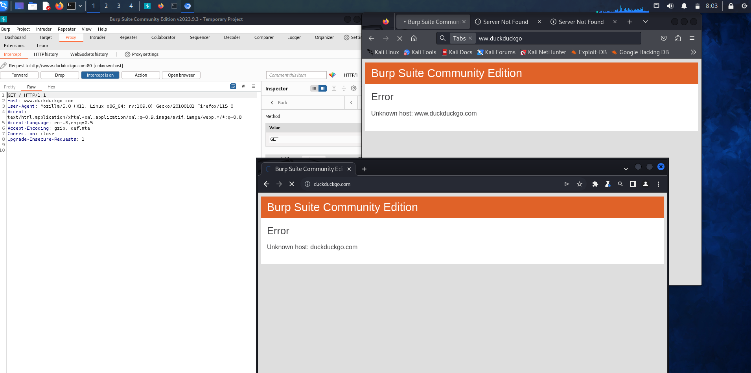

In the above screenshot, I used burpsuite community edition to intercept the browser when trying to open duckduckgo.com and able to intercept the request using burpsuite. I configured the firefox proxy for it and we can do the same using the inbuild chromium browser for this as well. The two windows on the right are firefox and chromium browsers.

**Part B: Passive Reconnaissance with Reconnaissance Tools**

The Harvester

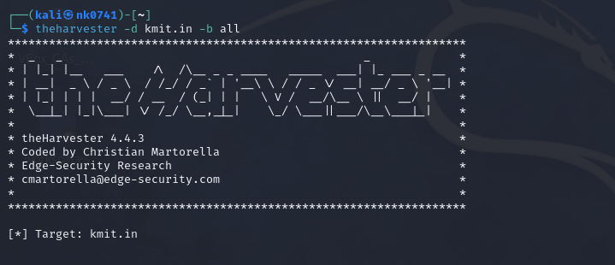

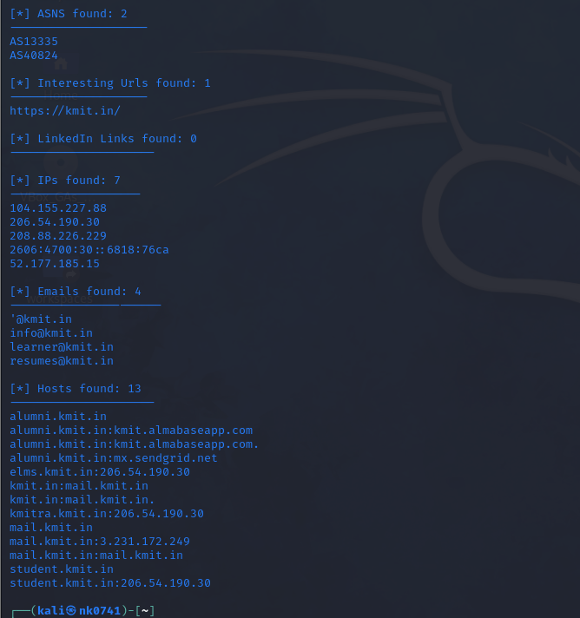

Analysis:

Here TheHarvester attempted to gather information such as emails, subdomains, hosts, ASNs (Autonomous System Numbers), interesting URLs, and LinkedIn links related to the domain "kmit.in". 7 IP addresses and 4 email addresses were identified as associated with the domain "kmit.in". The last list in the screenshot is the list of sub domains along with their IP addressess.

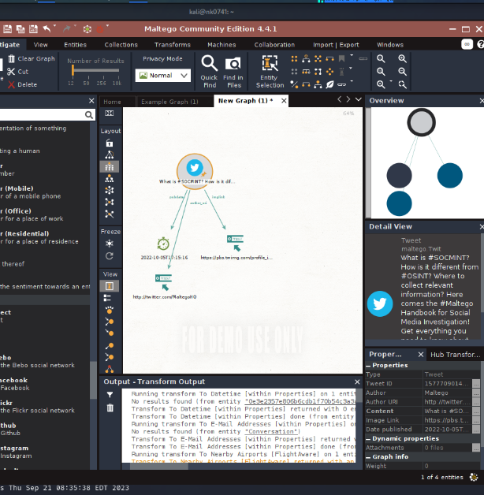Maltego : Below is the screenshot of using transform to find details on a tweet using maltego.

In this we used maltego to get all the ip addresses, metadata descriptors, server address that are linked to amazon.in using Censys and ip transforms.

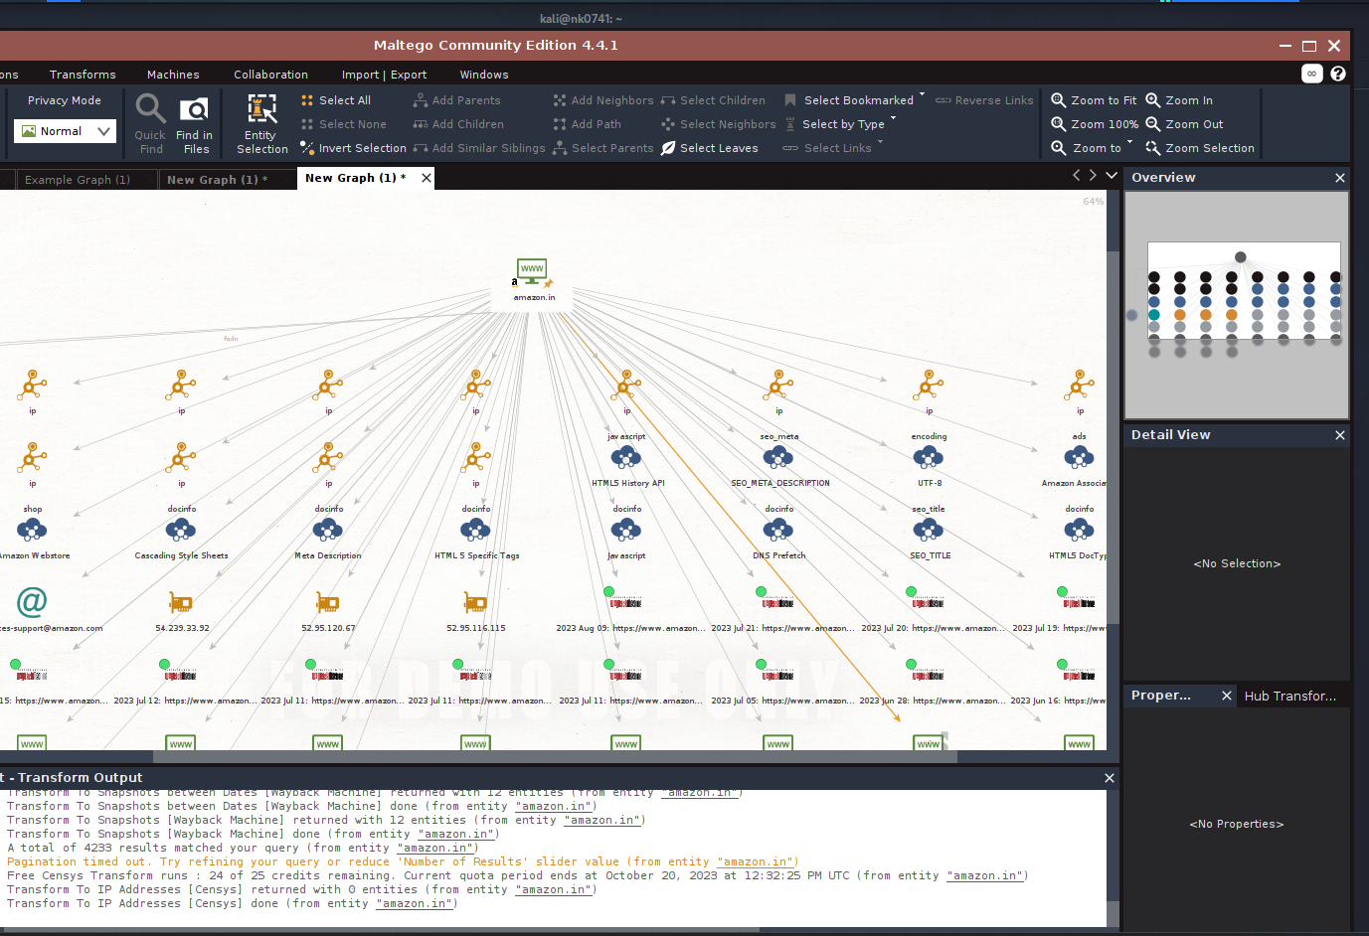

Spider Foot- from CLI

We used spriderfoot to make it go through the meesho.com website.

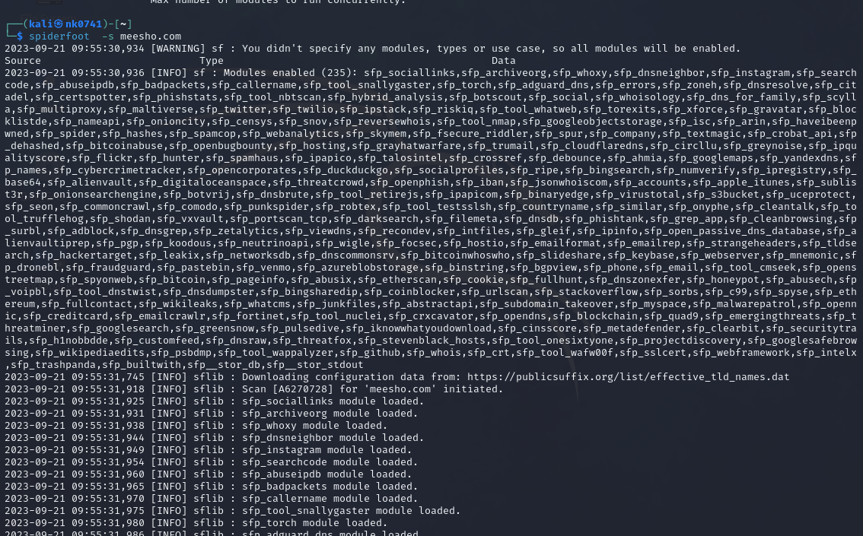

From below screenshot we get the information all the product listed in it and dns list. In the next screenshot containing the details of the digital certs used by meesho and there public details.

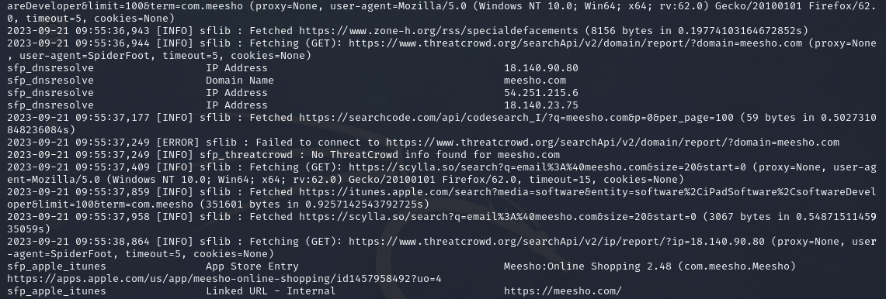

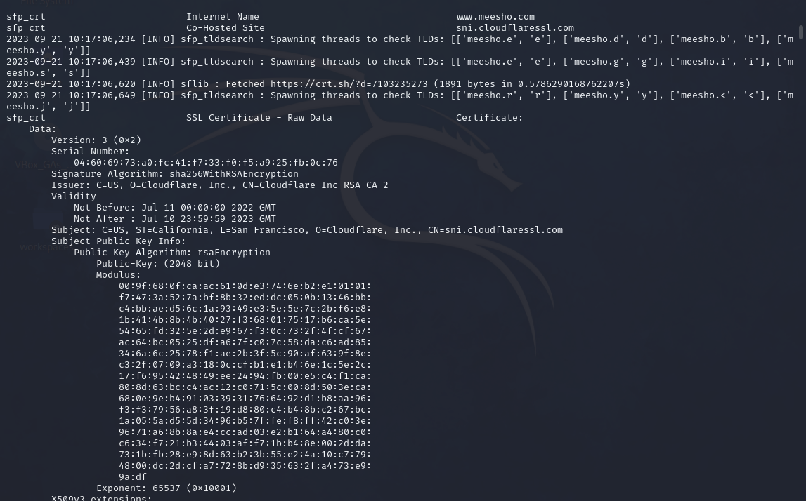

Spiderfoot from GUI:

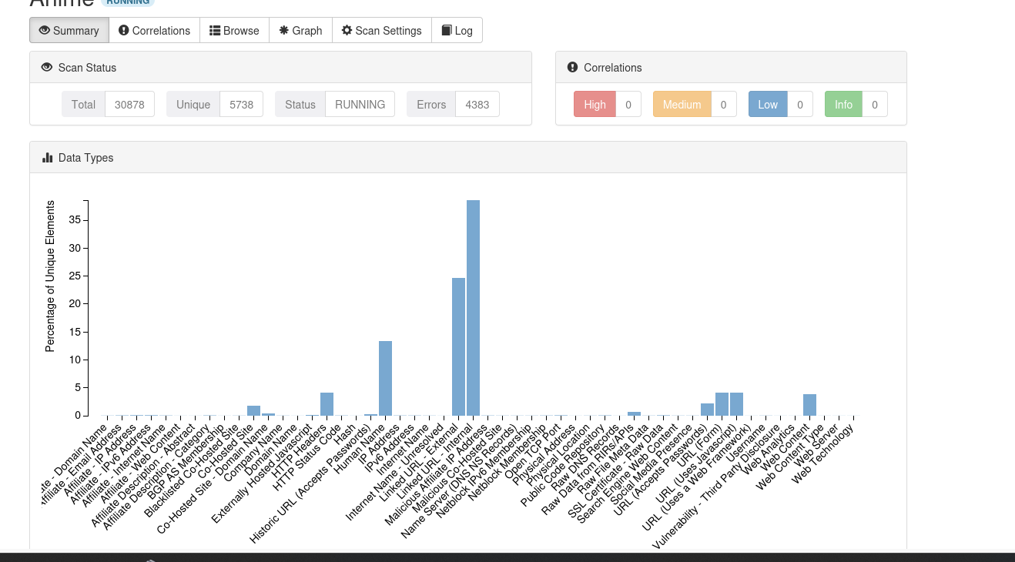

The graph showing all connections to the domain.

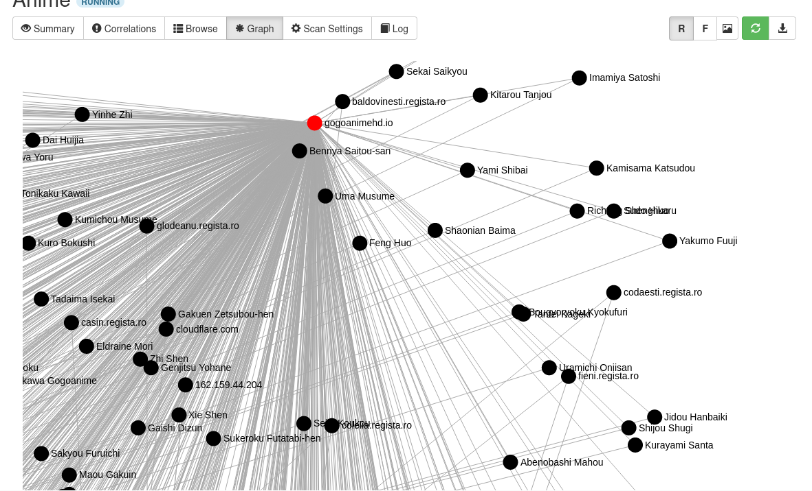

Shodan

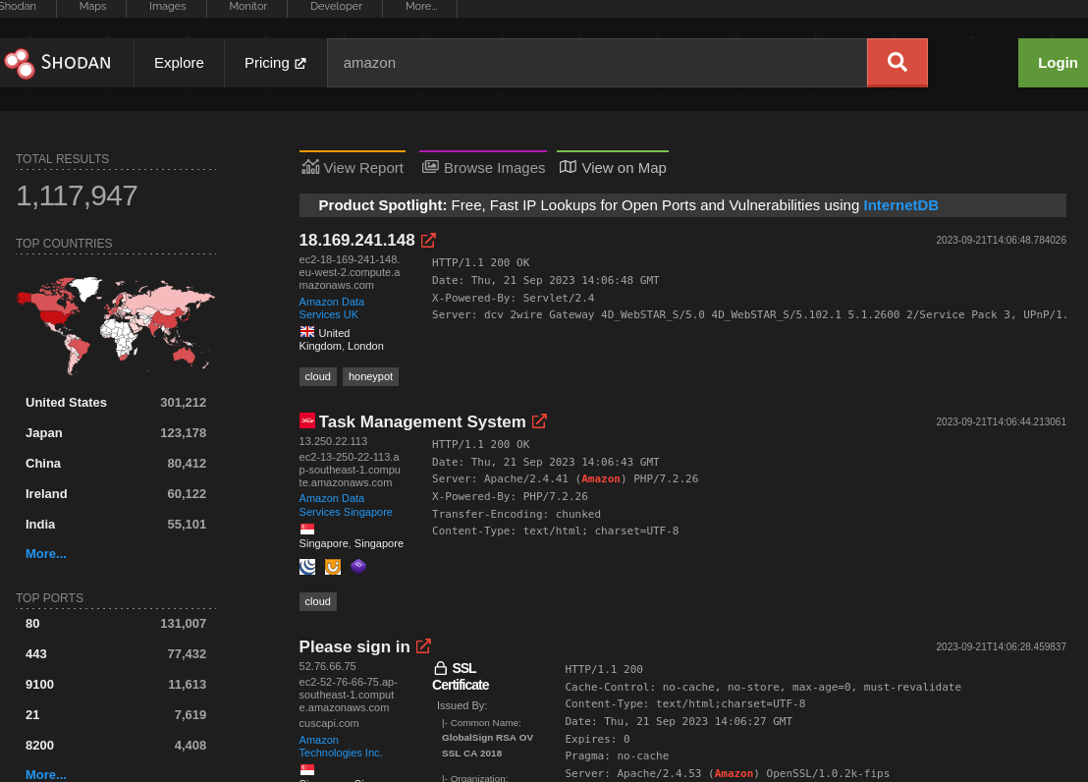

It gives info on list of servers and their IP addresses country they are present and ports which are used by it and many other details. We can even view IP cameras which are public.

ZoomEye.org: It is a search engine specifically designed for discovering and visualizing IoT (Internet of Things) devices, services, and vulnerabilities. It is primarily used for gathering open-source intelligence (OSINT) related to IoT devices and associated network services

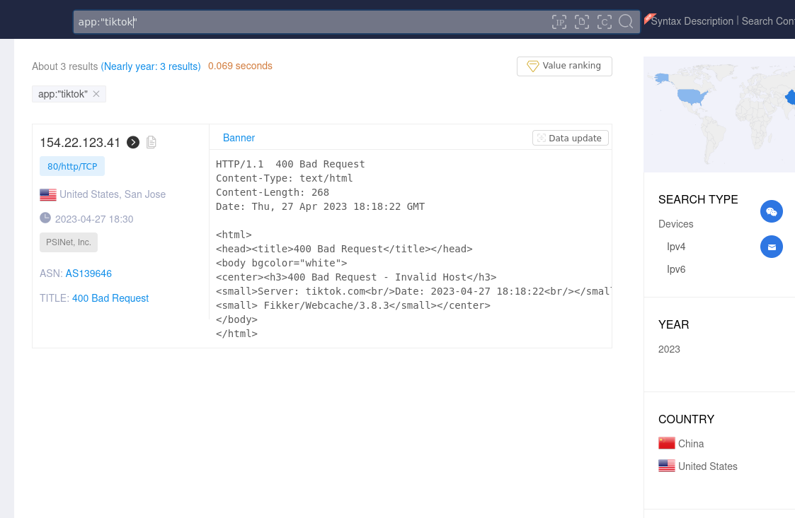

We can the iconhash for searching as well using zoomeye. Below is the screenshot where we amazon icon for doing the search.

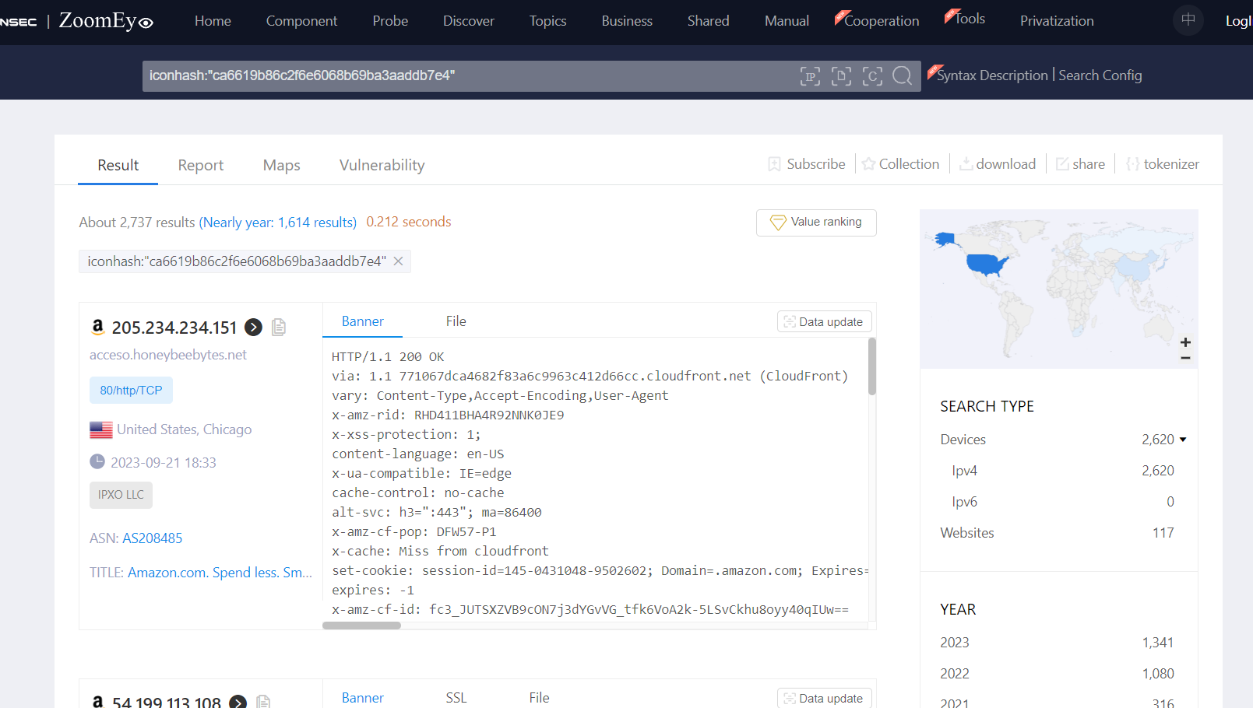

Censys.io

It gives the details where ip address is orginated and reverse dns, who it belongs to. Incidently we give the url to get the details where it orginates and what all ip addresses and it has option to generate report depending on user need. I used to generate report for location where it servers are present in the last screenshot.

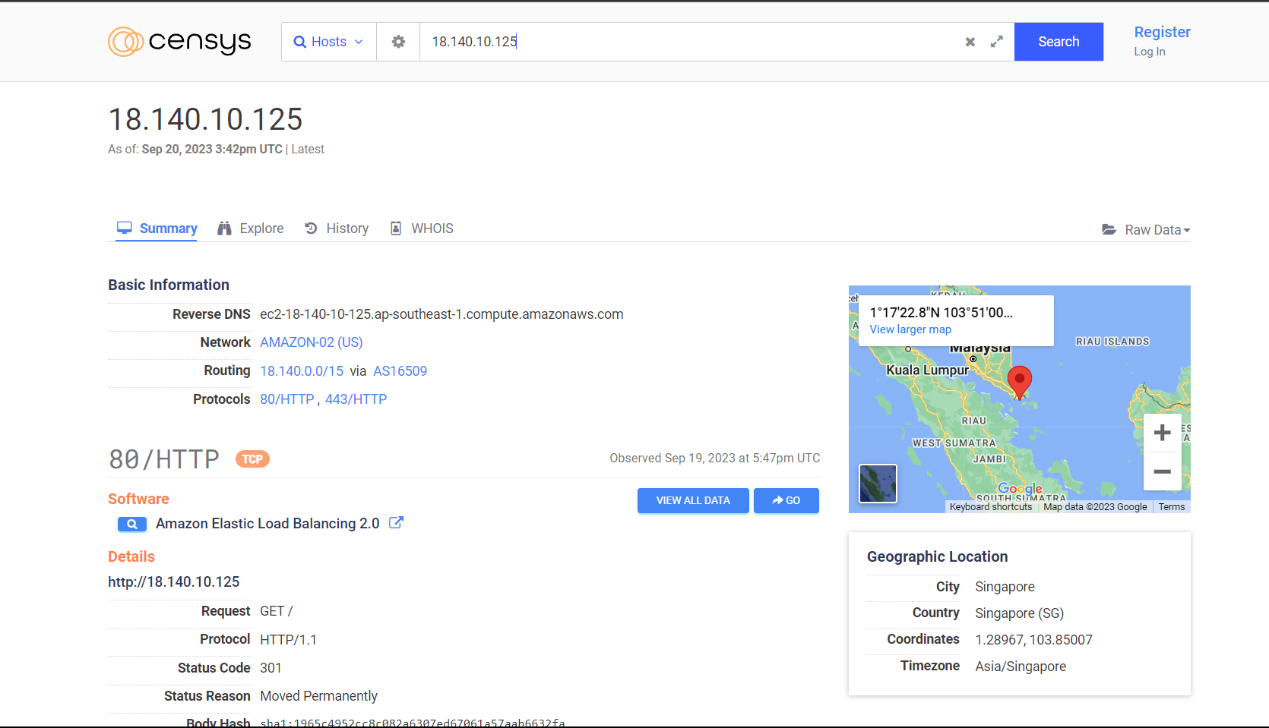

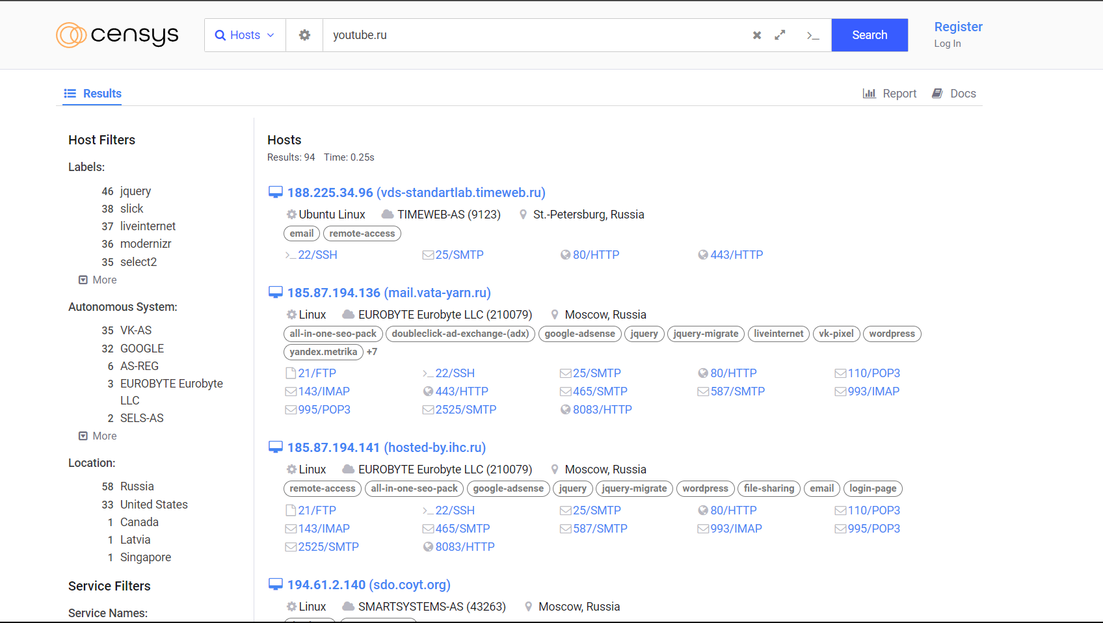

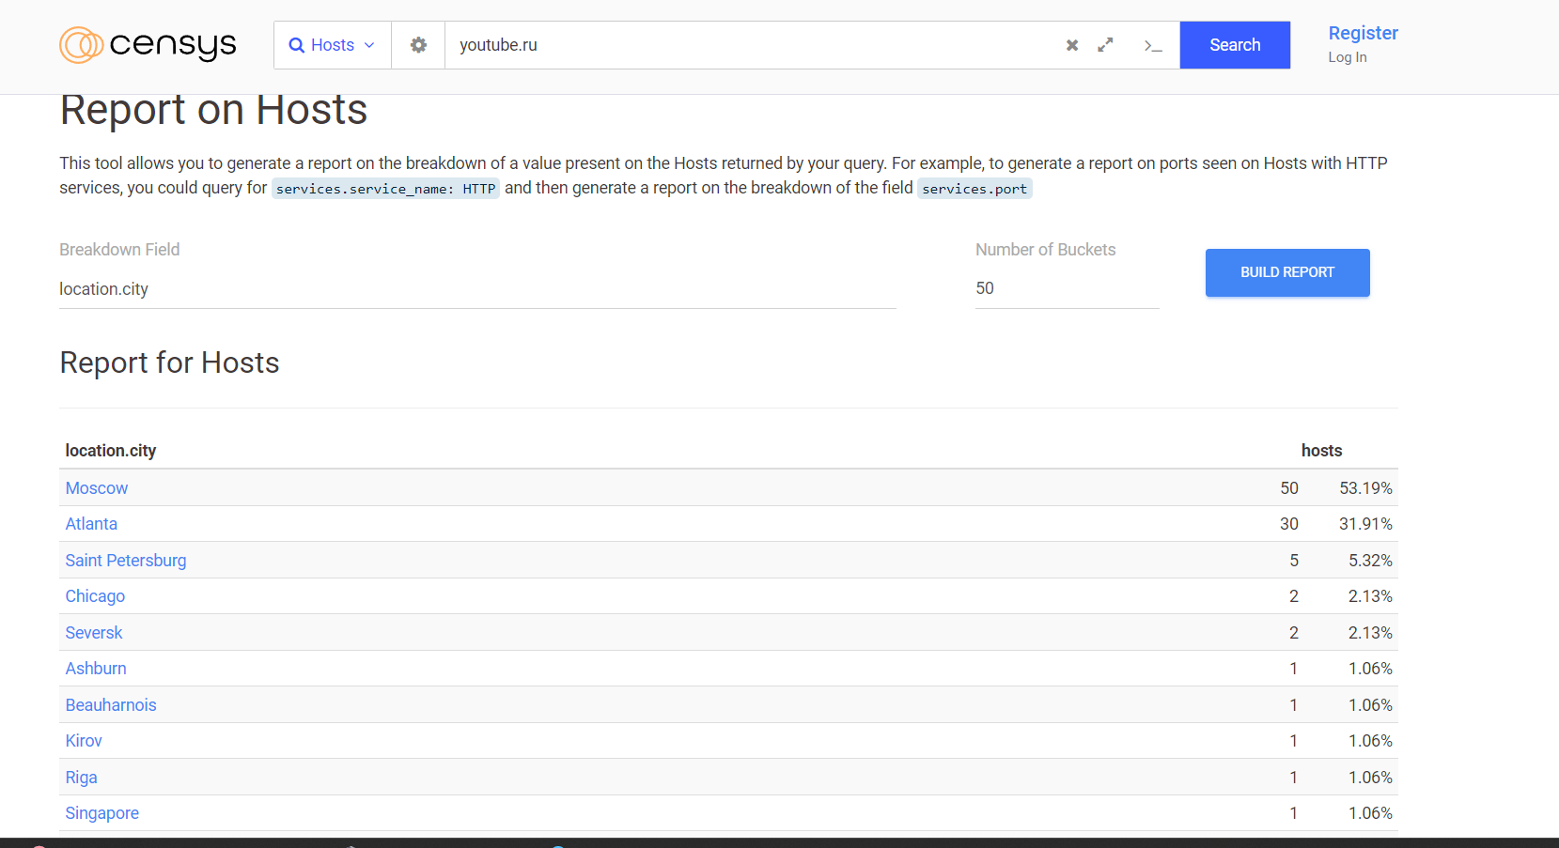

Spyse.com

I think Spyse.com got shutdown and no longer available to use. Below u can sniper use various tools which are integrated into it for using it.

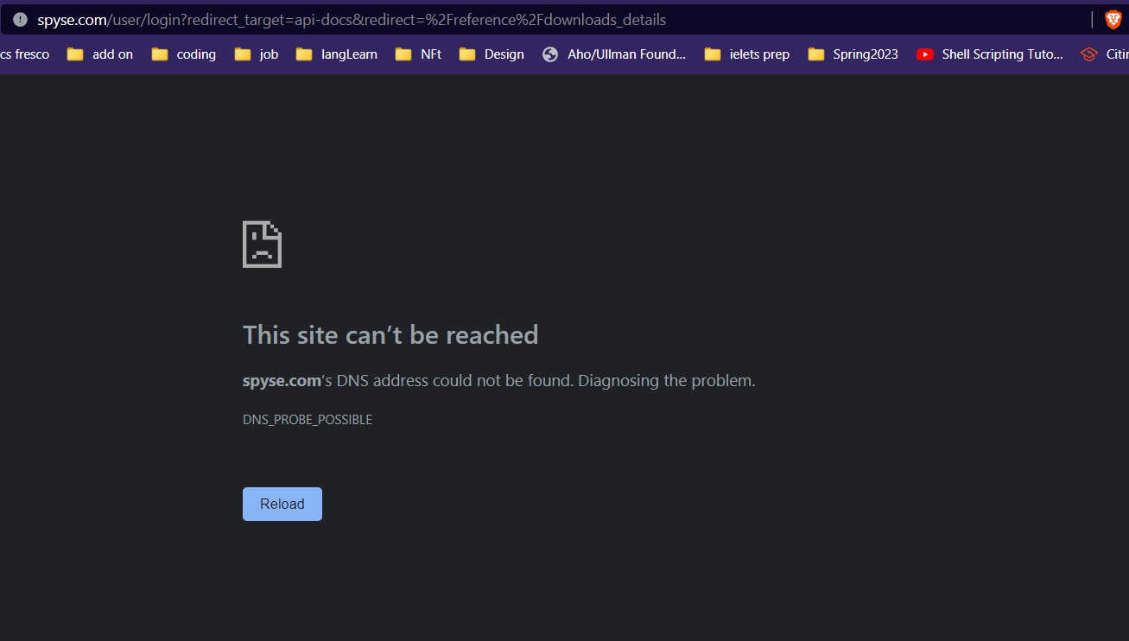

-

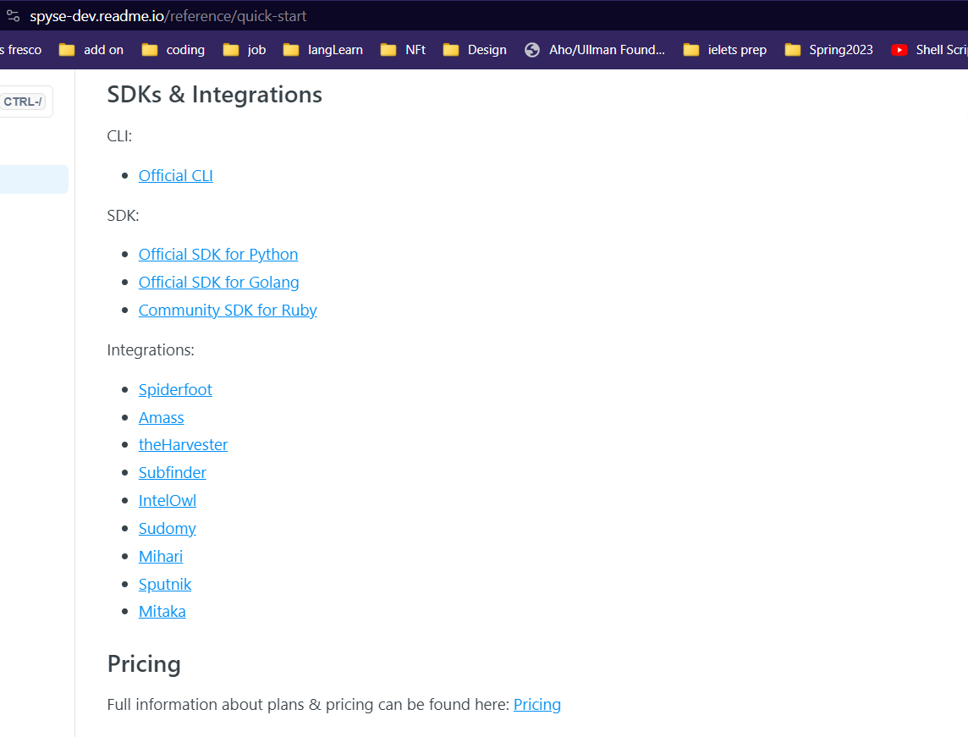

-

FOCA :

FOCA (Fingerprinting Organizations with Collected Archives) is a network intelligence tool used for analyzing metadata and information leaks in documents. I

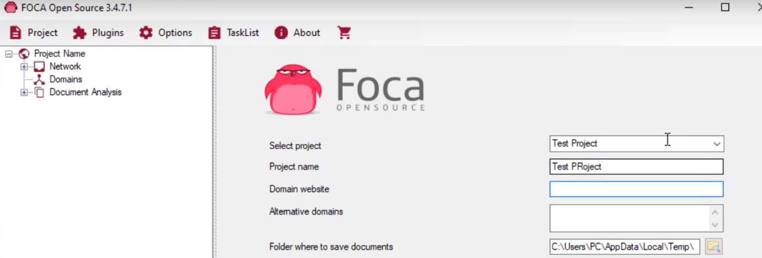

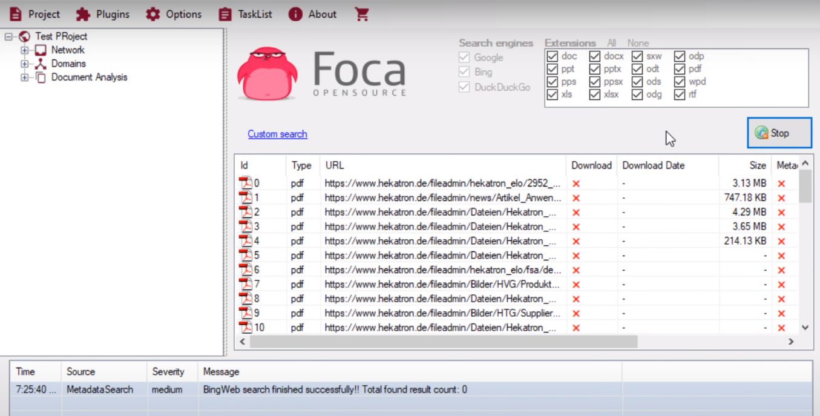

Have I Been Pwned : I used my two different emails to check if there are involved in any data breach or not. Below is the screenshot of the result.

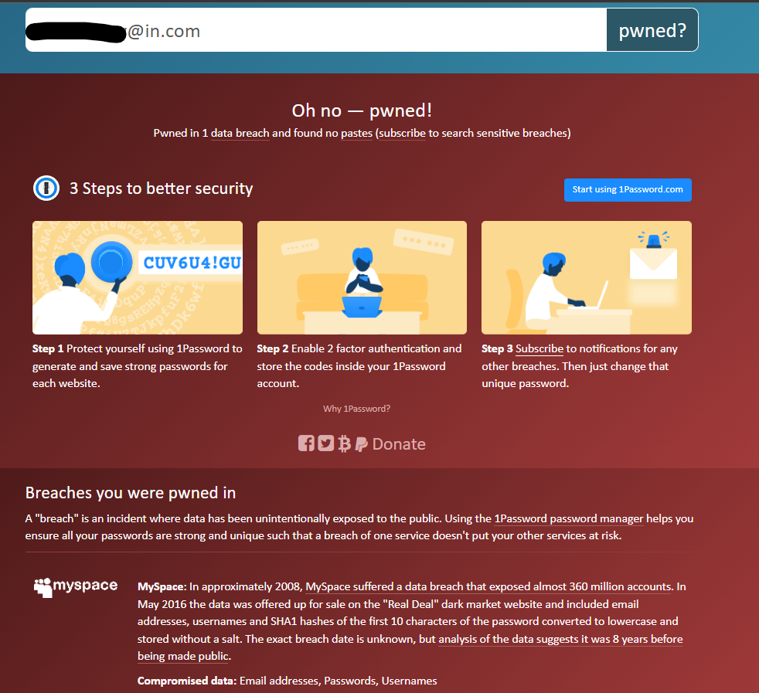

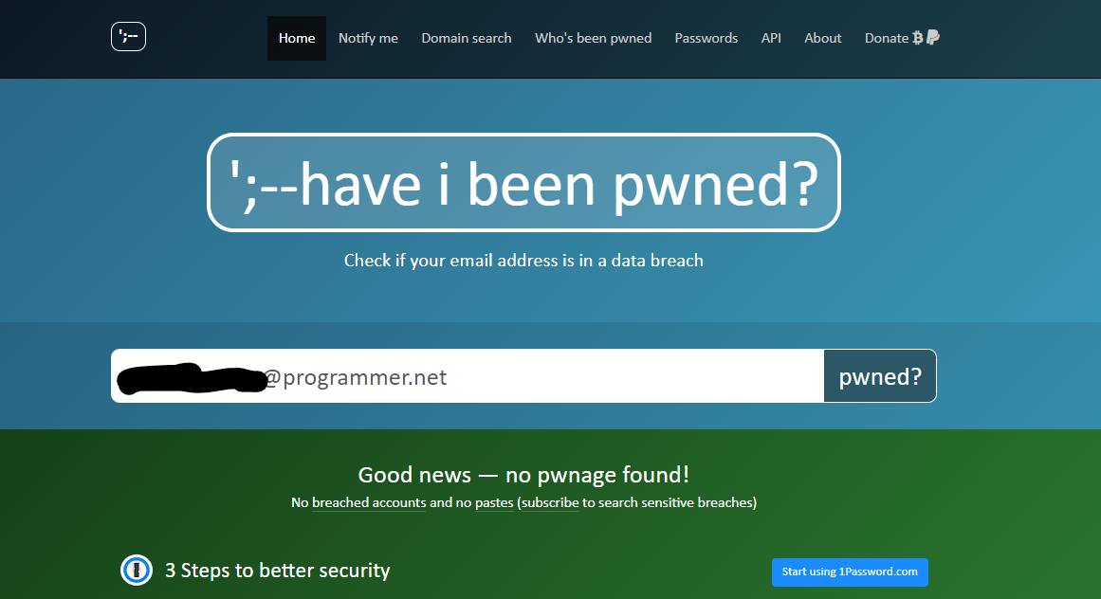

Extra:

SubFinder - Passive: Subfinder is considered a passive open-source intelligence (OSINT) tool used for subdomain discovery

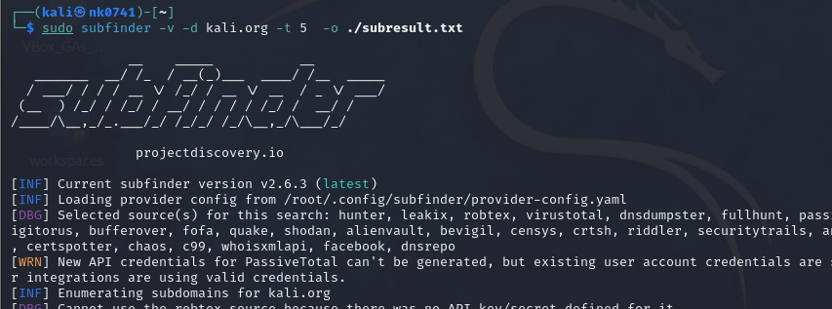

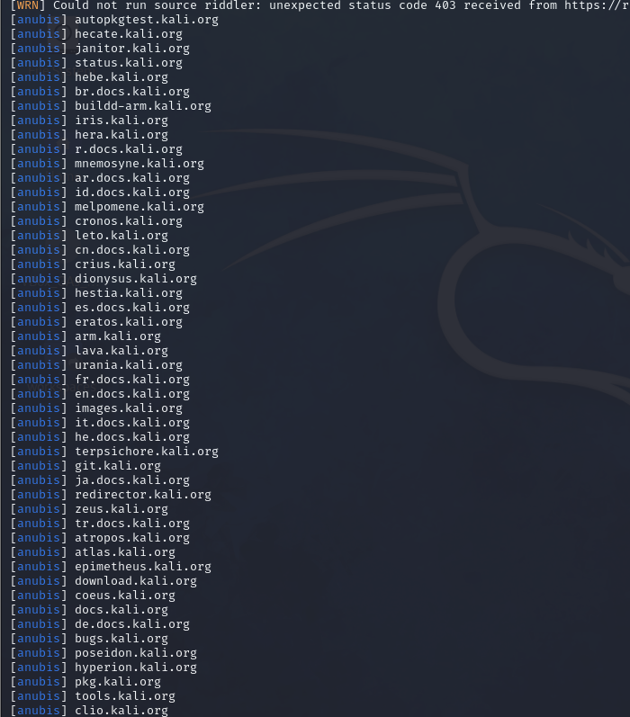

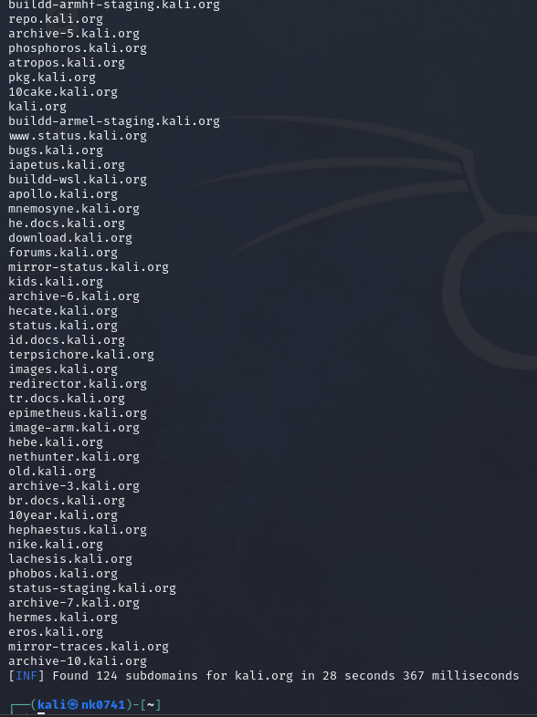

Knockpy- Passive: Knock is an passive tool. It is a Python tool for enumerating subdomains using common techniques like brute-forcing, Google scraping, and certificate transparency.

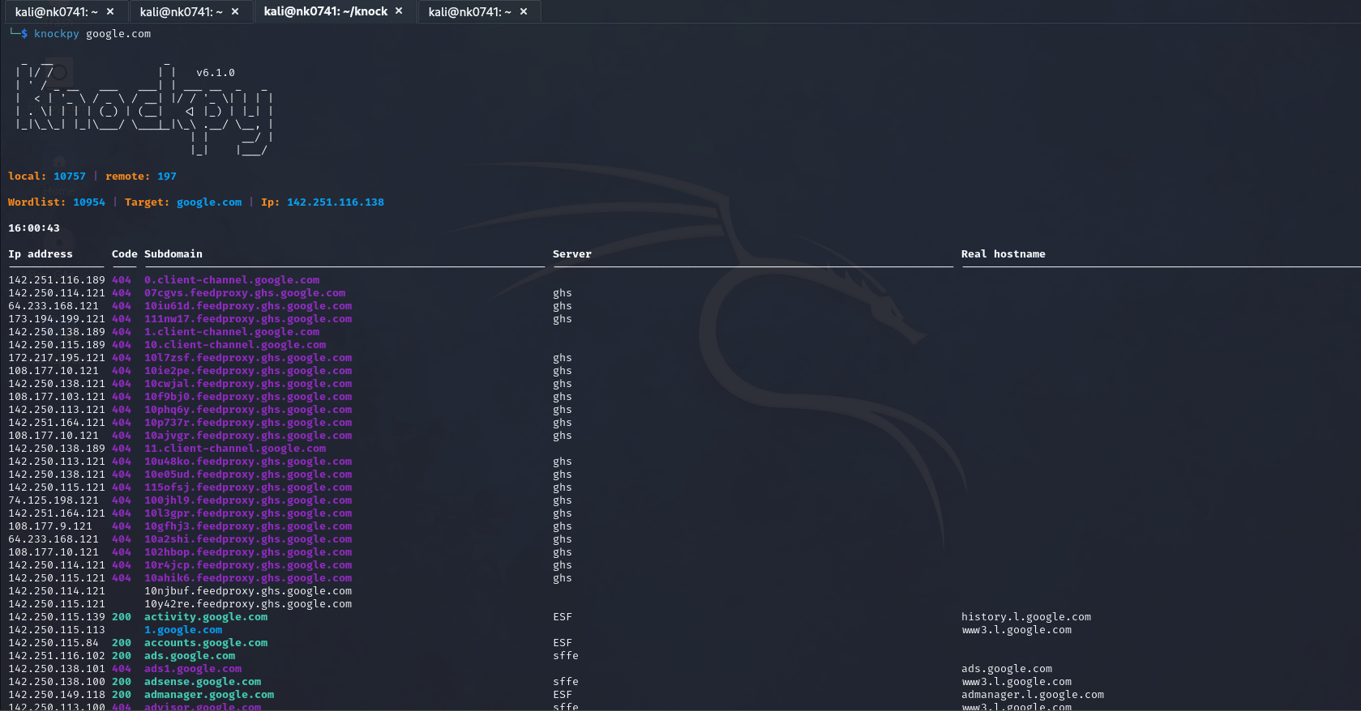

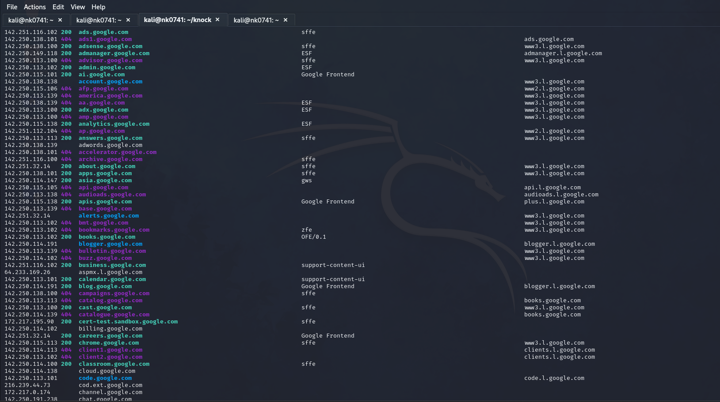

Hydra-active: Hydra is an active tool in the realm of cybersecurity and open-source intelligence (OSINT). It's a powerful and popular password-cracking tool, often used in penetration testing and security assessments to perform brute force attacks against various protocols such as SSH, FTP, Telnet, HTTP, and others.

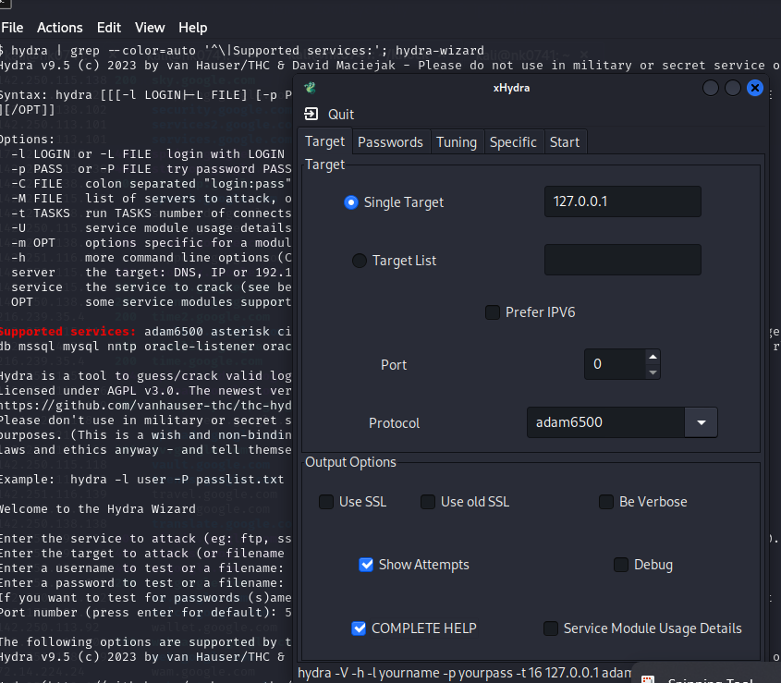

Some more tools:

* Sudomy: It is a subdomain enumeration tool written in Python that uses various techniques to discover subdomains.
* Subfinder2: It is an actively maintained fork of the original Subfinder with added features and improvements.
* BeEF: It is an open-source penetration testing tool used to test the security of web browsers. It allows ethical hackers, penetration testers, and security professionals to assess the security posture of a target by exploiting vulnerabilities in the browser.
* Gobuster: It is another popular directory and file brute-forcing tool designed to discover hidden directories and files on web servers. It's written in Go (hence the name) and is known for its speed and efficiency.
* Dirb: It is a popular web application directory brute-forcing tool used for discovering hidden directories and files on a web server. It's written in C and is often included in security testing toolsets due to its efficiency in finding common web application vulnerabilities.

Reference:

<https://www.freecodecamp.org/news/an-introduction-to-web-server-scanning-with-nikto/>

<https://www.geeksforgeeks.org/what-is-sublist3r-and-how-to-use-it/>

<https://www.youtube.com/watch?v=1AVppUSe7Sk>

<https://github.com/projectdiscovery/subfinder>

<https://github.com/guelfoweb/knock>

<https://medium.com/hacker-toolbelt/knokpy-5c6745e53770>

<https://www.youtube.com/watch?v=cw59-9s1XhE>

<https://github.com/vanhauser-thc/thc-hydra>

<https://github.com/ElevenPaths/FOCA>

<https://www.youtube.com/watch?v=ieRgYTwxSLA>

<https://medium.com/@drag0s.stanescu/pdf-metadata-and-practical-examples-of-how-to-handle-it-a6954fa2c374>

<https://www.hekatron.de/fileadmin/user_upload/testfolder/Sample.pdf>

Mitnick, K. (2019). The art of invisibility: The World’s Most Famous Hacker Teaches You How to Be Safe in the Age of Big Brother and Big Data. Back Bay Books.